**Lab Report 2**

For this lab report we used the flickr30 dataset provided by Mayanka, taking the sorted dataset from Lab 1, we used the Show and Tell model on the Football dataset using the code provided and got a full list of captions (beam search k=4) for the whole dataset.



Afterwards we had to perform accuracy statistics using the BLEU, CIDER, METEOR and ROGUE measures. We did the BLEU statistics using the code provided by Mayanka, for 5 different images from the dataset.

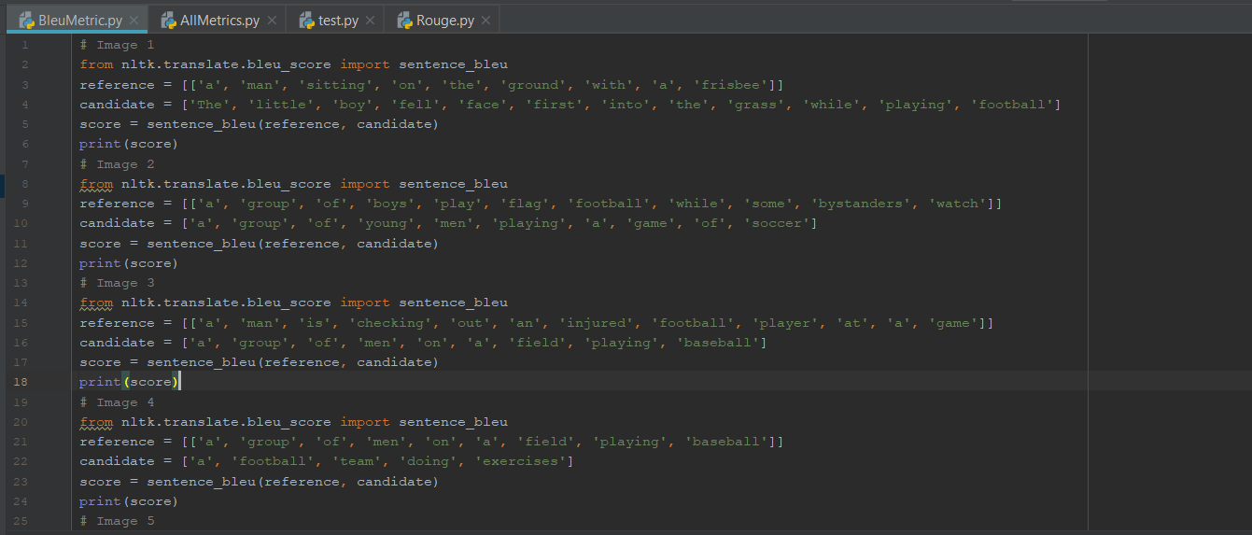

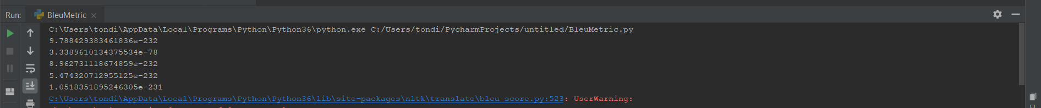

We did ROUGE accuracy statistics using code found at <https://github.com/pcyin/PyRouge>, performing it on 1 image caption from the dataset.

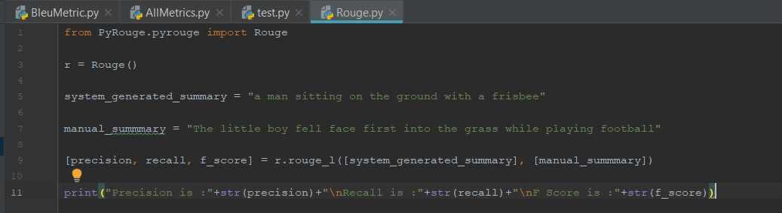

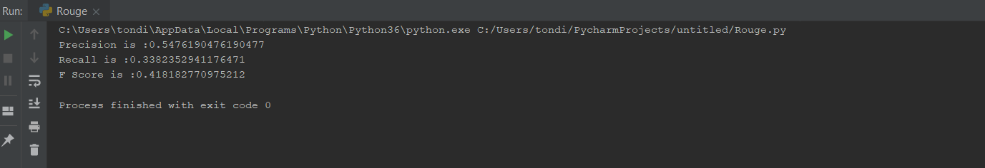

We performed CIDER and METEOR accuracy statistics using code found at <https://github.com/Maluuba/nlg-eval>. It actually provided BLEU and ROGUE statistics aswell.

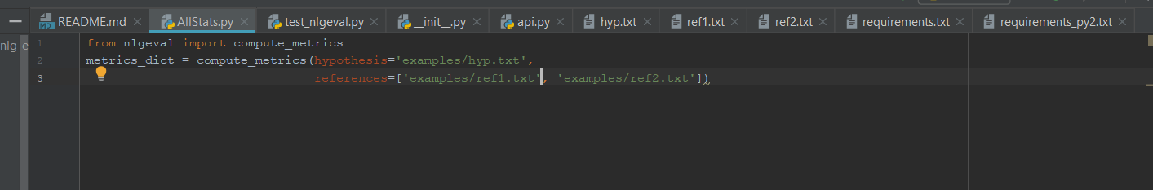

<https://drive.google.com/file/d/1ZBeAbK8MTn1FB-o5bIYlowtAyD3BPjLU/view?usp=sharing>

The github repo can be found at <https://github.com/TondiToday/CS5542/lab2>